**Name- Sayali Machhindra Jagtap**

**Roll no- 20U436**

**Assignment no: 1**

**DFS :**

// DFS algorithm in C++

#include <iostream>

#include <list>

using namespace std;

class Graph {

int numVertices;

list<int> *adjLists;

bool *visited;

public:

Graph(int V);

void addEdge(int src, int dest);

void DFS(int vertex);

};

// Initialize graph

Graph::Graph(int vertices) {

numVertices = vertices;

adjLists = new list<int>[vertices];

visited = new bool[vertices];

}

// Add edges

void Graph::addEdge(int src, int dest) {

adjLists[src].push_front(dest);

}

// DFS algorithm

void Graph::DFS(int vertex) {

visited[vertex] = true;

list<int> adjList = adjLists[vertex];

cout << vertex << " ";

list<int>::iterator i;

for (i = adjList.begin(); i != adjList.end(); ++i)

if (!visited[*i])

DFS(*i);

}

int main() {

Graph g(5);

g.addEdge(1, 0);

g.addEdge(0, 2);

g.addEdge(2, 1);

g.addEdge(0, 3);

g.addEdge(1, 4);

cout << "Following is Depth First Traversal\n";

g.DFS(0);

return 0;

}

**Output :**

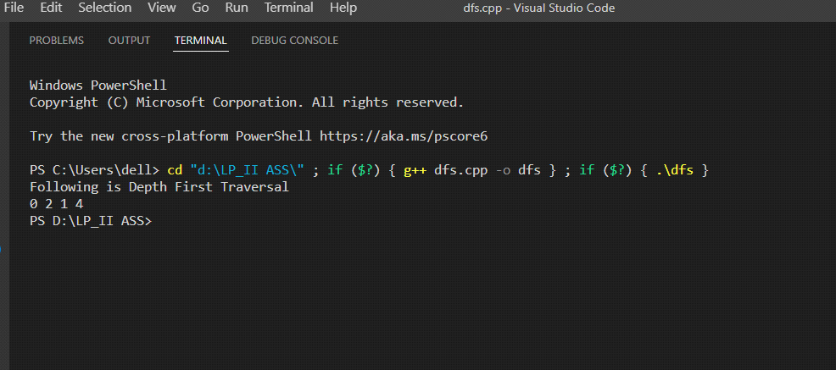

**BFS :**

#include<iostream>

#include <list>

using namespace std;

// This class represents a directed graph using

// adjacency list representation

class Graph

{

int V; // No. of vertices

// Pointer to an array containing adjacency

// lists

list<int> *adj;

public:

Graph(int V); // Constructor

// function to add an edge to graph

void addEdge(int v, int w);

// prints BFS traversal from a given source s

void BFS(int s);

};

Graph::Graph(int V)

{

this->V = V;

adj = new list<int>[V];

}

void Graph::addEdge(int v, int w)

{

adj[v].push_back(w); // Add w to vs list.

}

void Graph::BFS(int s)

{

// Mark all the vertices as not visited

bool *visited = new bool[V];

for(int i = 0; i < V; i++)

visited[i] = false;

// Create a queue for BFS

list<int> queue;

// Mark the current node as visited and enqueue it

visited[s] = true;

queue.push_back(s);

// 'i' will be used to get all adjacent

// vertices of a vertex

list<int>::iterator i;

while(!queue.empty())

{

// Dequeue a vertex from queue and print it

s = queue.front();

cout << s << " ";

queue.pop_front();

// Get all adjacent vertices of the dequeued

// vertex s. If a adjacent has not been visited,

// then mark it visited and enqueue it

for (i = adj[s].begin(); i != adj[s].end(); ++i)

{

if (!visited[*i])

{

visited[*i] = true;

queue.push_back(*i);

}

}

}

}

// Driver program to test methods of graph class

int main()

{

// Create a graph given in the above diagram

Graph g(4);

g.addEdge(0, 1);

g.addEdge(0, 2);

g.addEdge(1, 2);

g.addEdge(2, 0);

g.addEdge(2, 3);

g.addEdge(3, 3);

cout << "Following is Breadth First Traversal "

<< "(starting from vertex 2) \n";

g.BFS(2);

return 0;

}

**Output :**

